Mathematical Image Processing in Art Conservation
Stephany Palmer

1 | Introduction:
The main objective of modern art conservation is reversibility. The introduction of digital recoloration using mathematical image processing techniques perfectly meets the requirements of restoring a painting to a version more similar to what the artist intended without the possible consequences of physical conservation techniques that are sometimes difficult to correct.
2 | Standard Art Restoration:
Art conservation aims to preserve the art piece in question at its current condition, reverse any material decay, and delay further restoration for as long as possible. Each art piece has its own unique conditions for maximum efficiency and best results for conservation, depending on the original technique of its artist and what materials were used in the making of the piece.
Common physical methods of art conservation used in the past as well as the present include stabilization, surface cleaning, the removal of discolored varnish, the repair of tears and punctures, filling areas of paint loss, and expert retouching.
2.1 | Causes Of Damage To Paintings:
Many things can cause damage to an art piece, leaving it in need of conservation:
a) Wear & Tear, which includes any mishandling of the art since its creation.
b) Degradation, of any of the materials used in the art piece.
c) Censorship, a famous example being Michelangelo’s David with a modesty fig leaf added by the Catholic church.
d) Iconoclasm, defined as attacking established values and practices.
e) Previous conservation attempts, unfortunately also on this list, as past conservators were unaware of the long-term effects of their materials and techniques.

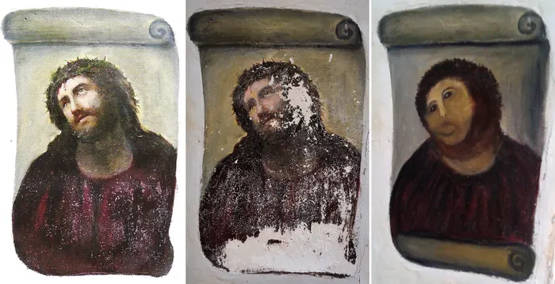
A fresco’s evolution from its (approximated) original state to its deteriorated state
Just by the nature of a paper canvas, deterioration is destined for any painting that has not been preserved conscious of the weaknesses of paper. Paper can deteriorate due to photomechanical reactions--being exposed to any light can weaken the paper if it has not been grounded with a primer. Also, paper made in the century after 1850 was acidic due to additives added in the mechanical process for short-term strengthening. The oxygen bridges in the cellulose fibers are susceptible to acid hydrolysis, which breaks the glucose chaining and weakens the cellulose fibers, letting the paper become hard and brittle, leaving it to disintegrate easily. The hydroxyl groups in cellulose are also prone to oxidization, and high lignin content in the paper causes it to turn yellow.
Paint can crack and become brittle due to humidity levels; if no primer underneath, paint can seep in between the paper fibers, which allows light to go through and the painting becomes translucent. Warping in the frame of a painting also makes the handling of it more difficult and dangerous to transport.

3 | Mathematical Image Processing:
Mathematical image processing involves digitally analyzing and processing an image to correct it for visual imperfections that results in the work of the conservator not being distinguishable from that of the original art.

3.1| Digital Restoration:
The basic techniques of digital restoration include recoloration—to correct for the sepia affect that degraded varnishes and paper gives paintings—and inpainting by transferring the information available in the intact areas of the image to the damaged areas in the image.

4 | Digital Restoration by Example:
There are many different digital restoration methods, one method outlined in the paper Arora’s “Digital restoration of old paintings” describes recoloring an old using the color space of a clean sample painting using statistics and matrix manipulations.
First, calculate the mean of pixel data along all three axes R, G and B for both the old and sample cleaned painting, denoted as (${\overline{R}}_{old}$, ${\overline{G}}_{old}$, ${\overline{B}}_{old}$) and (${\overline{R}}_{clean}$, ${\overline{G}}_{clean}$, ${\overline{B}}_{clean}$) respectively.
Then calculate the covariance matrices for both the paintings ${Cov}_{old} and {Cov}_{clean}$.
$$Cov=\left(\begin{matrix}cov(R,R) & cov(R,G) & cov(R,B) \\ cov(R,G) & cov(G,G) & cov(G,B) \\ cov(R,B) & cov(G,B) & cov(B,B)\end{matrix}\right)$$
Now, decompose the covariance matrix using singular value decomposition, an algorithm used to decompose a large amount of complicated data into three vital matrices.
$$Cov=U*S*V^{T}$$
U and V are unitary matrices and are composed of eigenvectors of Cov, while S is a diagonal matrix of the eigenvalues of Cov.
Transformations are applied to Cov using the following transformation matrices:
Rotation: $R_{old}=U_{old}, R_{clean}=U_{clean}^{-1}$
Translation: $T_{old}=\left(\begin{matrix}1 & 0 & \begin{matrix}0 & {\overline{R}}_{old}\end{matrix} \\ 0 & 1 & \begin{matrix}0 & {\overline{G}}_{old}\end{matrix} \\ \begin{matrix}0 \\ 0\end{matrix} & \begin{matrix}0 \\ 0\end{matrix} & \begin{matrix}\begin{matrix}1 & {\overline{B}}_{old}\end{matrix} \\ \begin{matrix}0 & 0\end{matrix}\end{matrix}\end{matrix}\right),T_{clean}=\left(\begin{matrix}1 & 0 & \begin{matrix}0 & {\overline{R}}_{clean}\end{matrix} \\ 0 & 1 & \begin{matrix}0 & {\overline{G}}_{clean}\end{matrix} \\ \begin{matrix}0 \\ 0\end{matrix} & \begin{matrix}0 \\ 0\end{matrix} & \begin{matrix}\begin{matrix}1 & {\overline{B}}_{clean}\end{matrix} \\ \begin{matrix}0 & 0\end{matrix}\end{matrix}\end{matrix}\right)$
Scaling:$S_{old}=\left(\begin{matrix}\begin{matrix}λ_{old}^{R} & 0 \\ 0 & λ_{old}^{G}\end{matrix} & \begin{matrix}0 & 0 \\ 0 & 0\end{matrix} \\ \begin{matrix}0 & 0 \\ 0 & 0\end{matrix} & \begin{matrix}λ_{old}^{B} & 0 \\ 0 & 1\end{matrix}\end{matrix}\right), S_{clean}\left(\begin{matrix}\begin{matrix}s_{clean}^{R} & 0\end{matrix} & \begin{matrix}0 & 0\end{matrix} \\ \begin{matrix}\begin{matrix}0 & s_{clean}^{G}\end{matrix} \\ \begin{matrix}0 & 0\end{matrix} \\ \begin{matrix}0 & 0\end{matrix}\end{matrix} & \begin{matrix}\begin{matrix}0 & 0\end{matrix} \\ \begin{matrix}s_{clean}^{B} & 0\end{matrix} \\ \begin{matrix}0 & 1\end{matrix}\end{matrix}\end{matrix}\right), where s_{clean}^{i}=\frac{1}{\sqrt{λ_{clean}^{i}}}$

The final transformation applied to each pixel of the painting will have the following form:
$$I=T_{clean}*R_{clean}*S_{clean}*S_{old}*R_{old}*I_{old}$$
With the homogeneous coordinates of the pixel points for the result and old painting denoted by:
$$I={\left(R,G,B,1\right)}^{T}, I_{tgt}={\left(R_{tgt},G_{tgt},B_{tgt},1\right)}^{T}$$

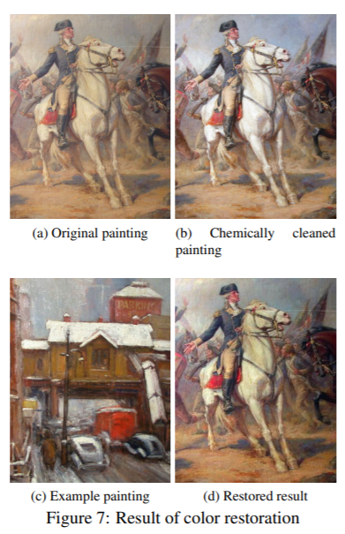
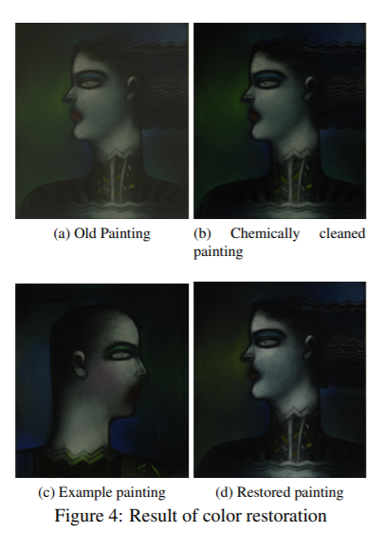

From Arora, in figure 4 we can compare the results aesthetically of digital restoration from an example painting(d) versus the chemically cleaned painting(b). As you can see from figure 7, an example painting does not need to be a reconstruction or copy of the original, it just needs to be a painting with a similar color palette to have a reasonable restored result.

5 | Similarity Metric:
To be able to quantifiably measure how faithful or similar the digitally restored or chemically cleaned results are to the original painting for quality assurance, one method used is finding the Kullback-Leibler divergence between the result and the original color space. The lower the KL-divergence is between the result and the original, the more similar the result is to the original. Thus, in order to get a more similar digitally restored painting, the example painting chosen must have a similar color distribution to the original. In order to assess if the new sample painting has similar color distribution to the old painting, perform eigen-space transformations followed by the KL-divergence calculation.
5.1 | KL-Divergence:
The Kullback-Leibler divergence is a non-symmetric measure of the difference between two probability distributions P and Q. KL measures the expected number of extra bits required to code samples from P when using a code optimized Q, rather than using a code based on P. With P being the observed distribution of data; Q approximating P.$$D_{KL}(P|\left|Q\right)=\sum_{i}{P(i)}ln\frac{P(i)}{Q(i)}$$
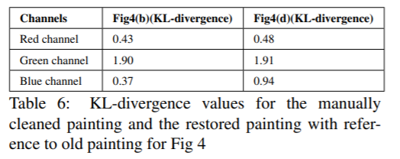
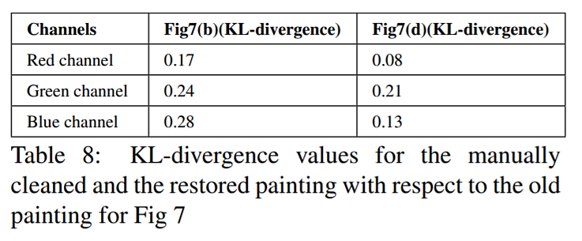
To the right we have a table comparing the KL-divergence calculations for the chemically cleaned(b) versus the digital restoration(d) from figure 4. The chemically cleaned painting had a lower KL-divergence for each of the color channels compared to the digitally restored painting, so (b) is the more similar restoration attempt to the original.
To the right we have a table comparing the KL-divergence calculations for the chemically cleaned(b) versus the digital restoration(d) from figure 7. Since (d) had a lower KL-divergence for each color channel, this time the digitally restored painting is more similar to the original, even though the example painting used to create it was a completely different painting from the original.
6 | Further Research:
Besides 2d restoration, art conservators are also exploring 3d restoration projects. A general overview of a 3d restoration project follows as:
Step 1: Generate a rough 3d model of the scene with plausible parameters.
Step 2: Generate masks for all objects in painting(by hand or segmentation).
Step 3: Project masks onto 3d model and project original image as texture onto objects.
Step 4: Add virtual cameras.
Step 5: Inpaint what was hidden from view in original scene.
Included in “Unveiling the invisible: mathematical methods for restoring and interpreting illuminated manuscripts” are additional files that have animations of the paintings “Annunciation” and “Scream” converted to 3d.
On the British museum’s webpage and their Facebook, they have a video of the 3d conservation of Xiang Sheng Mo’s Reading in the Autumn mountains.
7 | Conclusion:
Seeing how horribly a well-intentioned conservation attempt can pan out, digital restoration is the way to go for the future. From the results of Arora’s study, digitally restoration results’ KL-divergence is comparable to that of chemically cleaning, so a sufficiently similar image to the original painting is produced, reversing the effects of deterioration without the risks of physical restoration.
7.1 | Reflection:
Further research into other methods used to help conservators physically restore a painting interests me. Having a faithful image representing a restored version of the original painting is great, but to also have the original work is much more valuable to me and to others, I imagine.
The feedback from the class was more positive than I was expecting. I am not that strong of a public speaker, so after my presentation was over all I could think about was how I stumbled or how my voice shook. I had hoped that presenting over zoom would lessen my nerves, but now I know to rehearse my next presentation even more to be more confident. Everyone seemed to agree in that using several images helped them understand the overall concepts, so I will try to do that in my next presentation as well, though linguistics does not lend itself to having so many example images. I felt more confident explaining the results of the math methods used through example paintings than explaining the methods themselves, thus I have chosen my next math topic to be a bit simpler in concept, hopefully having my confidence in the topic shine through my presentation and making the concept clear for everyone.

References:
Brommelle, Norman Spencer, and Frank Zuccari. “Art Conservation and Restoration.” Encyclopædia Britannica, Encyclopædia Britannica, Inc., 2 June 2017, http://www.britannica.com/art/art-conservation-and-restoration
Calatroni, L., d’Autume, M., Hocking, R. et al. Unveiling the invisible: mathematical methods for restoring and interpreting illuminated manuscripts. Herit Sci 6, 56 (2018). https://doi.org/10.1186/s40494-018-0216-z https://heritagesciencejournal.springeropen.com/articles/10.1186/s40494-018-0216-z
“Conservation of Oil Paintings on Paper. From Ideas to Practical Solutions on the Example of Paintings by Estonian Artist Ado Vabbe.” Renovatum Anno, 5 Feb. 2019, https://renovatum.ee/en/autor/conservation-oil-paintings-paper-ideas-practical-solutions-example-paintings-estonian-artist
Daubechies, Ingrid. “Using Mathematics to Repair a Masterpiece.” Quanta Magazine, 29 Sept. 2016, www.quantamagazine.org/using-mathematics-to-repair-a-masterpiece-20160929/
N. Arora, A. Kumar, and P. Kalra. Digital restoration of old paintings. In International Conference in Central Europe on Computer Graphics, Visualization and Computer Vision (WSCG), June 2012, http://wscg.zcu.cz/WSCG2012/short/E61-full.pdf
Seery, Michael. “Paper Conservation.” RSC Education, 1 Mar. 2013, edu.rsc.org/feature/paper-conservation/2020204.article

