Math in Nature
Abstract: Nature is defined as “the phenomena of the physical world collectively, including plants, animals, the landscape, and other features and products of the earth”. Mathematics is defined as “the science of structure, order, and relation”. How are these two things related? The purpose of this paper is to demonstrate some of the ways that we see math in nature. Specifically, this paper explores the pervasiveness of the Fibonacci sequence and analogous golden ratio in the natural world. This paper is split into the following: 1) An introduction to the Fibonacci sequence, including its history and its relation to the golden ratio. 2) The formation of the Fibonacci spiral and some of its natural derivations. 3) Finding Fibonacci’s numbers in nature. 4) Why the Fibonacci sequence and golden ratio occur so often in nature. 5) A discussion on whether the prevalence of mathematics in nature is proof that math is naturally occurring and not created by humans. 6) Presentation reflection and peer feedback. [10][1]

- Introduction to the Fibonacci Sequence and Golden Ratio

1.1: History of Bonacci. Leonardo Bonacci was a talented Italian mathematician from the Republic of Pisa. In 1202, Bonacci published Liber Abaci - or “The Book of Calculation” - where he introduced a scenario about rabbit population growth in a biologically unrealistic setting following these 4 conditions:
  - A newly born pair of breeding rabbits (1 male & 1 female) are placed in a field
  - Each breeding pair of rabbits mates at the age of 1 month
  - Each month, each breeding pair of rabbits always produces another pair of rabbits (1 male & 1 female)
  - Rabbits never die and continue breeding forever
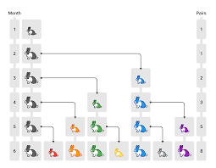
He posed the question: following these conditions, how many pairs of rabbits will there be in one year? He discovered that at the end of the n^{th} month, the number of pairs of rabbits is equal to the number of mature pairs plus the number of pairs alive last month. This can be reiterated as the number of pairs of rabbits at the end of the n^{th} month is equal to the number of pairs at the end of the month n-2 plus the number of pairs at the end of the month n-1 [7].
Figure 1: Bonacci's rabbit experiment results by month for 6 months

1.2: The Fibonacci Sequence. From the rabbit scenario, Bonacci discovered the sequence F_{n} = F_{n−1} + F_{n−2}. In 1838, a Franco-Italian historian gave Bonacci his more commonly known name: Fibonacci, short for fillius Bonacci (‘son of Bonacci’). Hence, the above sequence is known as the Fibonacci Sequence. The Fibonacci Sequence can begin from either 0 or 1. For the purposes of this paper, consider it to begin from 1. Following the sequence, the successive numbers would be 1, 1, 2 (1+1), 3 (1+2). 5 (2+3), 8 (3+5), 13 (5+8), 21 (8+13), … and so on forever [6][7].

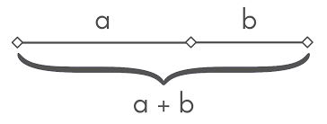
1.3: The Golden Ratio. In mathematics, two quantities are in the golden ratio, or phi, when the ratio of the smaller quantity to the larger quantity is equal to the ratio of the larger quantity to the sum of the two quantities. To derive phi, consider figure 2.
Figure 2: A line segment illustrating the derivation of the golden ratio. The ratio of a:b is equal to the ratio of a+b:a.
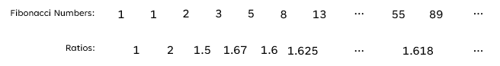
Let the length of b = 1 and the length of a = x. Then, by the definition of the golden ratio, (x+1)/x = x/1, which can be rewritten as x²-x-1 = 0 x = (1+√5)/2 = 1.6180339… = phi (Φ). The golden ratio can also be derived from the Fibonacci Sequence. As each successive number in the sequence is divided by its previous number (F_{n-1}/F_{n}), the ratio gradually approaches 1.618 = Φ. [3][4]
Notice that the ratios continuously oscillate from <1.618 to >1.618 as the Fibonacci sequence progresses. However, as n increases, the ratios become closer and closer to 1.618. Hence, phi is the limit of the Fibonacci Sequence.

- The Fibonacci Spiral

2.1: Formation of the Fibonacci Spiral. The Fibonacci spiral is a logarithmic spiral that follows the Fibonacci sequence. It is created by placing squares with side lengths coordinating to the Fibonacci sequence on a grid. Each square is placed adjacent to the previous one as shown in figure 3.
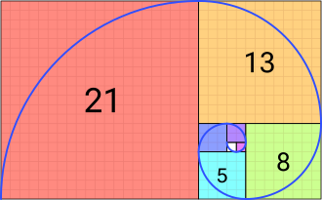
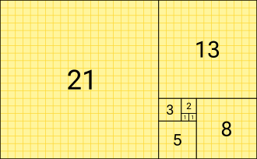
Starting from the first square placed with side length 1, an arc connecting opposite corners is drawn through each square, creating an outward spiral as the squares increase in size.
Figure 4: The Fibonacci spiral.
Figure 3: Foundational grid of the Fibonacci spiral following the Fibonacci sequence.
It is also important to note that since the spiral follows Fibonacci sequence’s proportions, the ratio of each successive square’s length approaches the golden ratio. For instance, using figure 4, the ratios 21/13 ≈ (21+13)/21. Calculating these ratios returns 1.615 and 1.619 respectively, both of which approach Φ = 1.618. [7]

2.2: The Fibonacci Spiral in Nature. Some notable examples of Fibonacci spirals in nature include the center of a sunflower, the pinecone, and the nautilus shell.
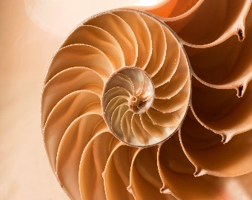
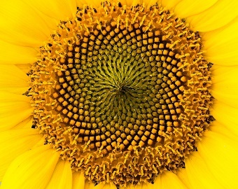
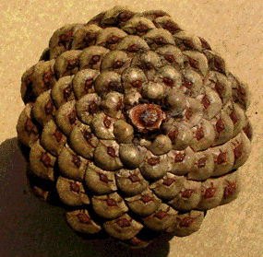
Figure 5: Examples of the Fibonacci spiral in nature.
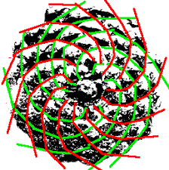
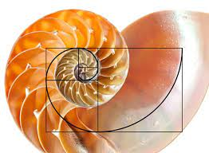
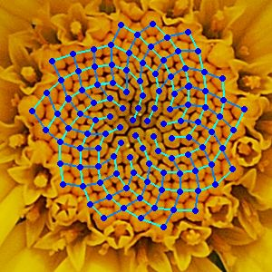
Figure 6: Illustrations of the natural Fibonacci spirals in these objects

- Fibonacci Numbers in Nature

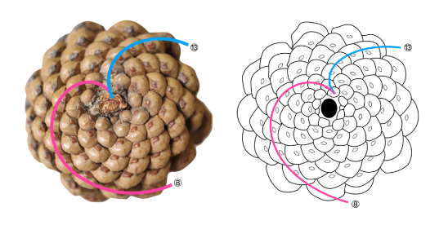
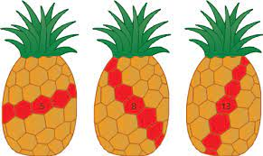
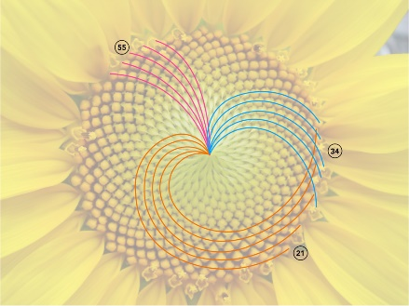
3.1: Fibonacci Numbers in Natural Spirals. Some objects in nature, such as the center of a sunflower and a pinecone as shown in figure 6, contain multiple spirals going in different directions. If one were to count the number of spirals going in each direction, they would find that the numbers coordinate with Fibonacci numbers. Additionally, the numbers would be successive Fibonacci numbers. For example, sunflower seed arrangements have spirals going in three directions. The number of spirals in different directions are 21, 34, and 55. This can also be denoted as F₈, F₉, and F₁₀ by the definition of the Fibonacci sequence. Further examples include the pinecone - which has 8, 13, and 21 (going vertically from the stem) spirals– and the pineapple – which has 5, 8, and 13 spirals going in different directions. [7]
8
13
8
13
Figure 7: Finding Fibonacci numbers in natural Fibonacci spirals. The number of spirals in different directions correlate with successive Fibonacci numbers.
3.2: Fibonacci Numbers in Flower Petals. Fibonacci numbers can often be found in the number of flower petals on certain flowers. However, the presence of Fibonacci numbers in flower petals is considered more of a tendency than a strict rule. It is still an intriguing phenomenon worth mentioning, though. The daisy can be found with 21, 34, 55, and 89 petals – all Fibonacci numbers. Other flowers can also be found with petal counts coordinating with Fibonacci numbers such as the calla lily with 1 petal, the euphorbia milii with 2, the trillium with 3, the buttercup with 5, the bloodroot with 8, and the marigold with 13. Although, it is important to note that these petal counts are averages. This does not mean that every single buttercup, for example, has 5 petals. It means that, on average, buttercups tend to have 5 petals. It is also significant to consider that the number of petals a flower has in nature is impacted by genetic influences and environmental factors. For instance, petals can be disconnected by the wind, passing animals or humans, or other natural and unnatural disturbances. [5]

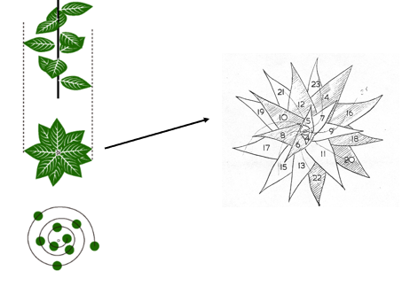
3.3: Phyllotaxis. Phyllotaxis is defined as the arrangement of leaves on a plant stem. There are many types of arrangements, but the most notable in terms of the Fibonacci sequence are alternate/spiral leaf patterns. With this arrangement, leaves are positioned at a fraction of a rotation from each other. Therefore, no two leaves arise from the same level or directly on top of one another. An aerial view of this arrangement shows multiple layers of leaves with little to no gaps.
Figure 8: Side and aerial view of a spiral leaf pattern on a plant.
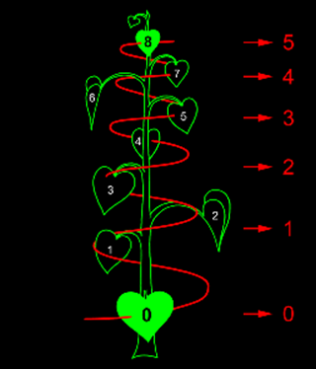
When referencing a plant’s phyllotaxis, it is often expressed as a fraction with the number of plant stem rotations over the number of leaves. To find the number of rotations, a spiral is drawn up the plant stem through every leaf. The number of full rotations is denoted as the numerator and the number of leaves passed through is denoted as the denominator. Figure 9 illustrates a plant with five rotations and eight leaves within those rotations, denoted with angle 5/8.
Figure 9: Demonstration of finding the angle (number of rotations/number of leaves) of a plant's phyllotaxis.
Natural examples include hazel with angle 1/3, apricot with 2/5, sunflower with 3/8, and willow with 5/13. Both the numerators and denominators exhibit Fibonacci numbers. [11]

- Why the Fibonacci Sequence and Golden Ratio are so Prevalent in Nature

4.1: Efficient Growth. Some argue that as natural spirals form, maintaining the same shape through each successive turn of the spiral uses the least amount of energy, making this the most efficient way for it to develop. Additionally, plants make use of spirals to ensure that leaves have maximum light exposure or ensure the best arrangement to produce the maximum number of seeds. For the purposes of this paper, the sunflower is a favorable example to demonstrate this phenomenon. The spirals found in the center of a sunflower are formed naturally as each new seed forms naturally after a turn from the previous seed. The purpose of this is to maximize the number of seeds it can hold in the available space. This is possible due to the golden ratio. [9]

4.2: The Golden Ratio and Seed Arrangement. Phi is an irrational number, meaning it cannot be expressed precisely as a fraction and the decimal representation continues infinitely without repetition. In fact, phi is known as “the most irrational of the irrational numbers”. Since the center of a sunflower is a circle (instead of a line), we must instead consider the golden angle. Similar to the golden ratio, the golden angle is found by sectioning the circumference of the circle according to the golden ratio such that the ratio of the smaller arc to the larger arc is the same as the ratio of the larger arc to the total circumference. The golden ratio is equal to the angle of the smaller arc, or 137.5 degrees. The center of the sunflower starts with one seed. Each succeeding seed is placed at a 137.5-degree angle from its predecessor, creating the same space between all seeds. This is the optimal filling of the center of the sunflower with seeds and the only arrangement that creates two spirals – one in each direction (figure 12). [4][8]

4.3: The Importance of Using the Golden Ratio for Seed Arrangement. As stated above, phi is considered the most irrational number. This is important because ratios that are simple fractions or can be closely approximated by a simple fraction will eventually turn into a pattern of stacked lines, creating gaps.
Figure 10: Seed arrangement at a 90-degree angle.
Figure 11: Seed arrangement at a 137.6-degree angle.
Figure 12: Seed arrangement at a 137.5-degree angle.
Figure 10 shows the arrangement of seeds that develop 90 degrees from each other. Since 90 degrees can be easily written as a simple fraction, the seeds are arranged in straight lines with large gaps in between. Figure 11 shows the arrangement of seeds that develop 137.6 degrees from each other. Notice that 137.6 degrees is only 0.1 degree more than the golden angle of 137.5 degrees. However, it is clear that while the seeds are not arranged in perfectly straight lines like they are in figure 10, there are still significant gaps between the rows of seeds. This simply goes to show that even the slightest variation in the angle between seeds can have a significant impact on their arrangement efficiency. Figure 12 shows the optimal arrangement formed with the golden angle. [9]

- The Philosophy of Math

5.1: The Origin of Math. Was mathematics invented to describe the world, or does the world conform to mathematical structures? This question has long been debated in the mathematical world. What is the human race’s role in mathematics – if any at all? According to philosopher Sam Baron from Australian Catholic University:

“Math is often described … as a language or a tool that humans created to describe the world around them, with precision. But there's another school of thought which suggests math is actually what the world is made of; that nature follows the same simple rules, time and time again, because mathematics underpins the fundamental laws of the physical world.
Instead, if we think of math as an essential component of nature that gives structure to the physical world, it might prompt us to reconsider our place in it rather than reveling in our own creativity” [4].

There are two sides to this debate: mathematical realists and mathematical anti-realists. The realists believe that mathematical objects exist independently from human thought and that mathematical truths are simply discovered rather than invented. They argue that mathematical entities have an objective existence and mathematical statements will be true or false regardless of if humans acknowledge them or not. The anti-realists believe that math is simply an idea that humans invented to describe patterns and relationships in the world.

Many argue that the considerable prevalence of mathematical phenomena in the natural world prove the beliefs of the realists are more accurate – That the strong connection between math and nature suggests a meaningful relationship between mathematical structures and physical reality. However, the subject is still up for debate. [2][12]

- Presentation Reflection
6.1: Personal Reflection. For this presentation, I really wanted to introduce something that I found interesting to the class. I love nature, so math in nature was simply something that I hoped would have a connection. When I started doing my research, though, I discovered that math and nature are much more interconnected than I ever realized. From the way that plants grow to the way that rivers run to natural logarithmic spirals, I discovered that math is everywhere around us. It seems like some people had already heard of some connections between math in nature before my presentation. I think I succeeded in expanding on these connections that people may have already heard of before. I also really liked the idea of taking the Fibonacci sequence, which we all already know or have at least heard of, and connecting it to our lives. As I expressed in class, I personally have learned about the Fibonacci sequence in my computer science courses more than anywhere else. However, I just knew it was a famous recursive function. I never realized where it came from or how prevalent it was all around us. The idea of taking something I already knew and connecting it to something I find really interesting was fascinating and also really helped me understand that the Fibonacci sequence is not just some impractical computer science concept. In terms of my presentation, I felt pretty good about it. I get pretty nervous talking in front of the class as many people do so I definitely forgot to say some things I meant to mention. I think for my next presentation, I just need to practice more and slow down a little so I have time to think instead of just trying to rattle off everything I can remember. Additionally, I know this presentation was a bit shorter than it should have been, so I really want to try and make sure that my next one is the appropriate duration.

6.2: Peer Feedback. After reading through the feedback on the discussion board, I got the impression that people enjoyed the topic of my presentation. A lot of people really liked the point I brought up about the philosophy of math and its origin. Many said they have had discussions on it before and that my presentation provided good evidence for proving the math realists’ beliefs. I also appreciated how some peers made other connections with some of the topics I introduced. For example, a few people mentioned the use of the golden ratio in art, which I did also read a little bit about in my research. I read that the golden ratio is very aesthetically appealing, which is why we find flowers so pretty. You can also find the golden ratio in the proportions of the face and in art, which are both beautiful things. Assuming that the golden ratio is a natural phenomenon, it is intriguing to see something naturally beautiful worked into something that is manmade.

REFERENCES
[1] Berggren, John L. , Fraser, Craig G. , Folkerts, Menso , Knorr, Wilbur R. and Gray, Jeremy John. "mathematics". Encyclopedia Britannica, 5 Mar. 2024, https://www.britannica.com/science/mathematics. Accessed 25 Mar. 2024.
[2] Blanchette, Patricia. “Realism in the philosophy of mathematics”. Routledge Encyclopedia of Philosophy, 1998, https://www.rep.routledge.com/articles/thematic/realism-in-the-philosophy-of-mathematics/v-1#:~:text=The%20antirealist%20argues%20that%20the,that%20mathematical%20knowledge%20is%20inexplicable. Accessed 25 Mar. 2024.
[3] Carlson, Stephan C.. "Golden Ratio". Encyclopedia Britannica, 3 Jan. 2024, https://www.britannica.com/science/golden-ratio. Accessed 25 Mar. 2024.
[4] Chasnov, Jeffrey. “2.2: The Golden Ratio”. LibreTexts Mathematics, 18 July 2022, https://math.libretexts.org/Bookshelves/Applied_Mathematics/Mathematical_Biology_(Chasnov)/02%3A_Age-structured_Populations/2.02%3A_The_Golden_Ratio#:~:text=Solution%20of%20(2.2.,irrational%20of%20the%20irrational%20numbers. Accessed 25 Mar. 2024.
[5] Clayton, Carolyn. Carolyn Clayton, 15 Mar. 2017, https://carolynclayton.co.uk/science/fibonacci-numbers-the-golden-ratio-in-flowers/. Accessed 25 Mar. 2024.
[6] “Fibonacci”. Wikipedia, 28 Feb. 2024, https://en.wikipedia.org/wiki/Fibonacci. Accessed 25 Mar. 2024.
[7] “Fibonacci Sequence”. Wikipedia, 18 Mar. 2024, https://en.wikipedia.org/wiki/Fibonacci_sequence. Accessed 25 Mar. 2024.
[8] “Golden angle”. Wikipedia, 15 Mar. 2024, https://en.wikipedia.org/wiki/Golden_angle#:~:text=In%20geometry%2C%20the%20golden%20angle,the%20larger%20arc%20to%20the. Accessed 25 Mar. 2024.
[9] Knott, Ron. “Fibonacci Numbers and Nature – Part 2. Why is the Golden section the “best” arrangement?”. 23 June 2017, https://r-knott.surrey.ac.uk/Fibonacci/fibnat2.html. Accessed 25 Mar. 2024.
[10] “Nature”. OED, Mar. 2024, https://www.oed.com/dictionary/nature_n?tab=factsheet#34906657. Accessed 25 Mar. 2024.
[11] “Phyllotaxis”. Wikipedia, 15 Mar. 2024, https://en.wikipedia.org/wiki/Phyllotaxis#:~:text=In%20botany%2C%20phyllotaxis%20(from%20Ancient,class%20of%20patterns%20in%20nature. Accessed 25 Mar. 2024.
[12] Watson, Clare. “What if Math Is a Fundamental Part of Nature, Not Something Humans Came Up With?”. sciencealert, 2 Jan. 2022, https://www.sciencealert.com/the-exquisite-beauty-of-nature-reveals-a-world-of-math. Accessed 25 Mar. 2024.

